**Project Design Phase**

**Problem – Solution Fit**

|  |  |
| --- | --- |
| Date | 09 February 2026 |
| Team ID | LTVIP2026TMIDS66199 |
| Project Name | TransLingua: AI-Powered Multi-Language Translator |
| Maximum Marks | 2 Marks |

**Problem – Solution Fit:**

The **Problem–Solution Fit** for *Explore with AI* focuses on addressing the common challenges faced by travelers in planning personalized trips efficiently and without stress.

**Purpose:**

❑ To solve the problem of language barriers by providing an AI-powered automated translation solution.

❑ To improve user adoption by aligning with modern behavior, where users prefer quick, web-based, and intelligent digital tools for real-time communication.

❑ To clearly communicate the value of AI-driven, context-aware translation as a faster and more reliable alternative to manual or traditional translation methods.

❑ To reduce common user frustrations such as inaccurate translations, high translation costs, time-consuming manual efforts, and lack of multilingual accessibility.

❑ To understand user communication needs and enhance the experience by delivering accurate, real-time, and multi-language translation through an easy-to-use web interface.

**Template:**

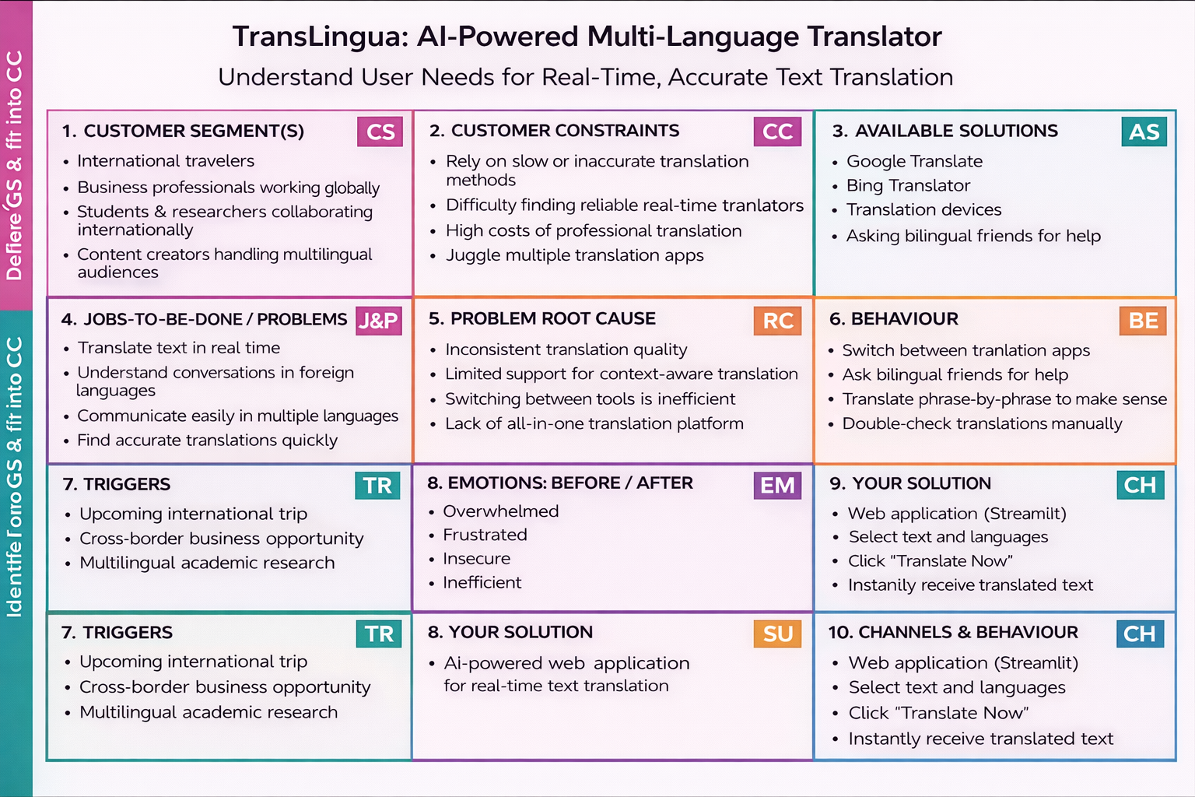

References:

1. <https://www.ideahackers.network/problem-solution-fit-canvas/>
2. <https://medium.com/@epicantus/problem-solution-fit-canvas-aa3dd59cb4fe>